Date: August 8, 2006
Student: Andrius Andrijauskas
TAs: Adam Barnett
Otto Goethals

Instructors: A.A. Arroyo
Eric M. Schwartz

University of Florida
Department of Electrical and Computer Engineering
EEL 5666
Intelligent Machines Design Laboratory

Final Report

Autonomous Warehouse Inventory Robot

Table of Contents

Abstract……………………………………………………………….3

Executive Summary……………………………….………………….3

Introduction……………………...……………………………………3

Integrated Systems.........................................................................…4-5

Mobile Platform………………………...…………………………….5

Actuation………………………………………..…………………….6

Sensors………………………………………………………..…...7-11

Behaviors………………………………………………...…………12

GUI………………………………………………………………12-13

Experimental Layout and Results………………….…………….13-14

Conclusion…………………………………………………………..14

Acknowledgements……….………………………………………...14

References………………………………………………..……....14-15

Appendices………………………………………………………….15

- Abstract

An Autonomous warehouse robot that is able to keep track of the warehouse inventory. This autonomous agent will roam the warehouse in a predetermined path and check the inventory. Inventory checking will be implemented using RFID system. Autonomous agent will contain an RFID reader. All containers entering the warehouse will be tagged with passive RFID tags, which contain information specific to the individual container. AWIR (autonomous warehouse inventory robot) will roam the warehouse using line following. Line to be followed will be strategically placed so that AWIR has easy access to any container in the warehouse. When the free roaming AWIR detects a container it will approach it (minimal distance required for a successful ID read) and read the passive tag enclosed within the container. Upon successful completion of RFID tag read, AWIR will relay information contained in the tag to a computer or a PDA via Bluetooth. Once the information about the scanned item has been successfully transmitted to the receiving device (computer/PDA), AWIR will continue to wander the warehouse.

- Executive Summary

AWIR is designed to supplement the warehouse inventory updating process. AWIR will roam the warehouse and attempt to scan each container, upon a successful scan, transmitting the container information to the warehouse PC.
AWIR contains numerous subsystems such as RFID system, actuation (motors, h-bridge, and line following), sonar, and communication. Please refer to “Sensors” section for more details on the individual systems.
Although there were some glitches and some bad times, overall AWIR project turned out to be successful. Autonomous agent behaved as expected, it is able to roam the warehouse in a predetermined path, at intersections choose random directions, scan containers, and after each successful scan transmit the information to the warehouse PC.

- Introduction

For any large distributor maintaining a sizable warehouse with a large inventory it is important to know exactly what is available. If a customer places an order and due to some human error the item that was suppose to be in the warehouse is no longer there, then the customer will receive an ordered item much later than anticipated. Orders received much later than anticipated upset customers as well as reflect badly on the company.
Autonomous Warehouse Inventory Robot will constantly wander the warehouse in a predetermined path and check its’ inventory. AWIR will be able to interface with warehouse computers via Bluetooth and update the inventory.
During this project a scaled down and somewhat simpler version of AWIR will be designed, built, and implemented.

- Integrated Systems

Control and signal processing for all of AWIR’s systems is implemented using Mavric IIB board from BDMicro, please refer to figure 1.
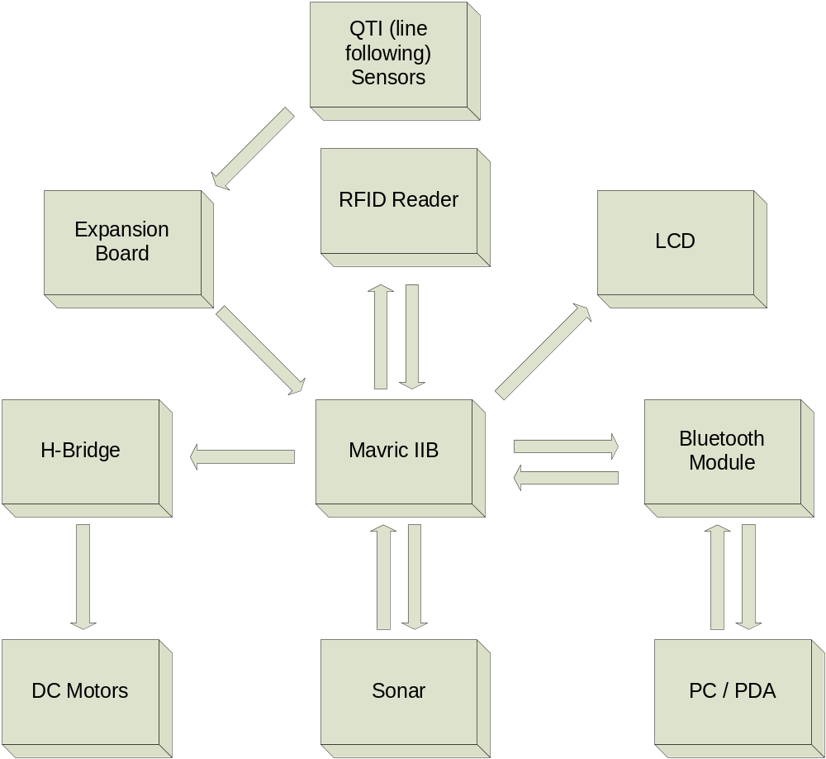
Figure 1
- QTI modules contain infrared sensors used for line following, for this project, QTI modules are used as analog sensors. QTI sensors are interfaced with Mavric IIB through A/D ports.

- Since RFID reader transmits its’ data serially, it is interfaced with hardware UART 1.

- LCD uses USART and can be connected to almost any pin, port B pin 7 in this case.

- H-bridge has special logic connections from Mavric IIB to control its’ behavior. For more details on H-bridge interface please refer to “Actuation” section.

- Bluetooth module is configured so that it is transparent, meaning that Tx pin from Bluetooth module is connected to Tx on UART 2 and Rx pin from Bluetooth module is connected to Rx pin on UART 2.

- Sonar is used for detecting an object in front of the robot. Sonar is interfaced with Mavric IIB through input capture pins.

- Serial LCD is used for limited feedback from the Mavric IIB board.

- PC contains software especially written to interface with AWIR, please refer to the section on GUI for more details.

- Mobile Platform

In order to minimize the size and reduce the weight, smallest possible design for the platform is preferable. The platform is only as big as to house all the necessary components and circuitry, as well as to accommodate for acceptably efficient actuation.
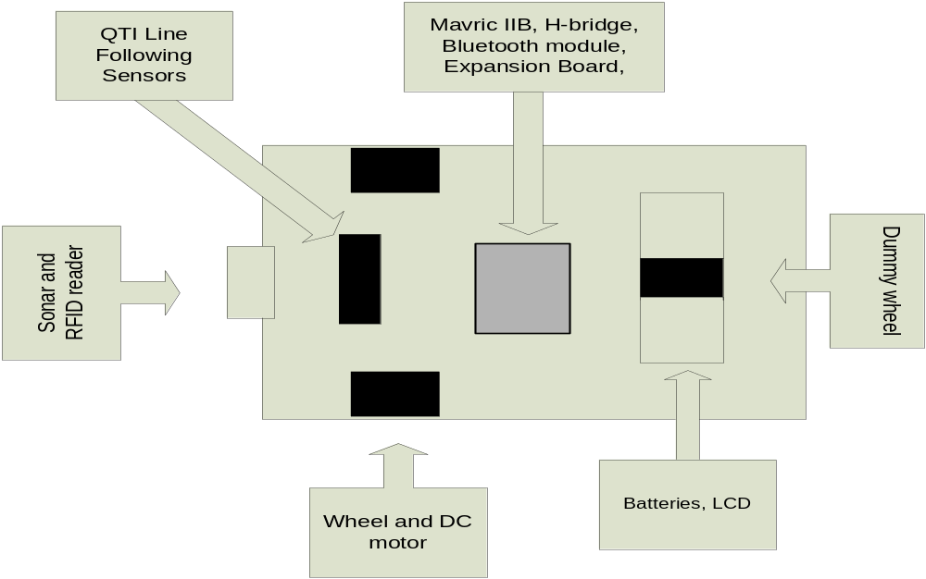Above is the basic layout (not to scale) of the platform. Please note that objects in black represent objects located on the bottom of the platform.
Figure 2

- Actuation

Robot actuation is implemented using two independent DC gearhead motors controlled by an H-bridge, figure 3.
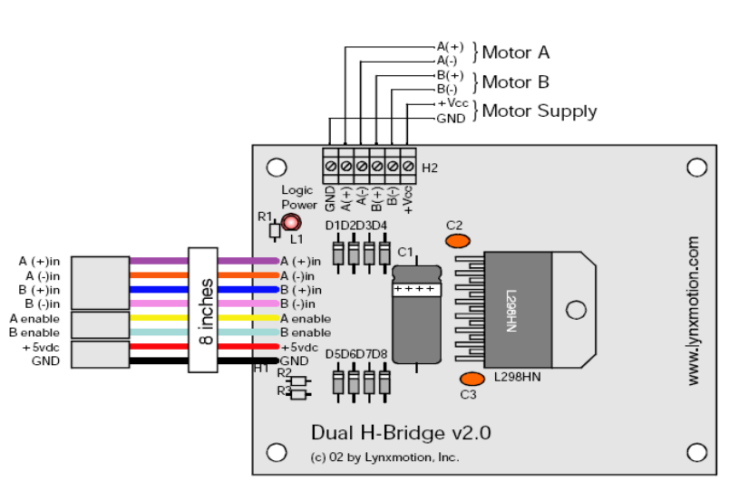
Figure 3
The H-bridge module uses the following truth table:
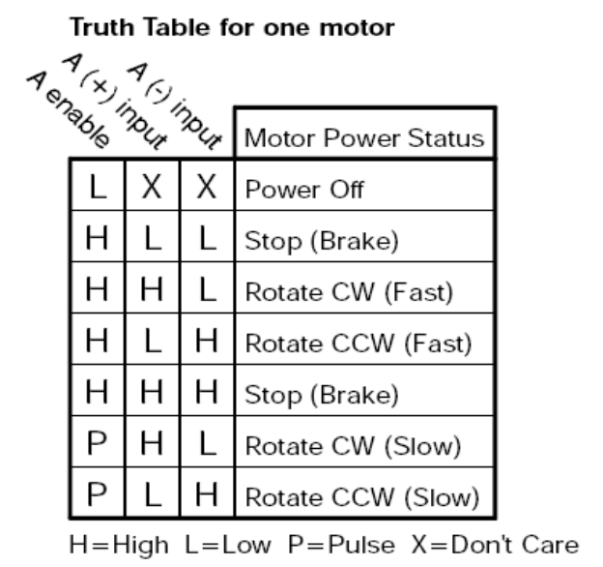
Figure 4
By pulsing the enable inputs on the H-bridge with PWM, speed of the motors can be easily controlled.
DC gearhead motors with the following specifications are used: 4mm shaft, 290 rpm, 43:1 gear ratio. Given relatively light weight and small size of the robot, this is enough to accommodate for efficient actuation. In order to avoid electrical “spikes” that could be caused by the DC motors, a separate 12V power supply is used to power the H-bridge and, in turn, the motors.

- Sensors

Line Following
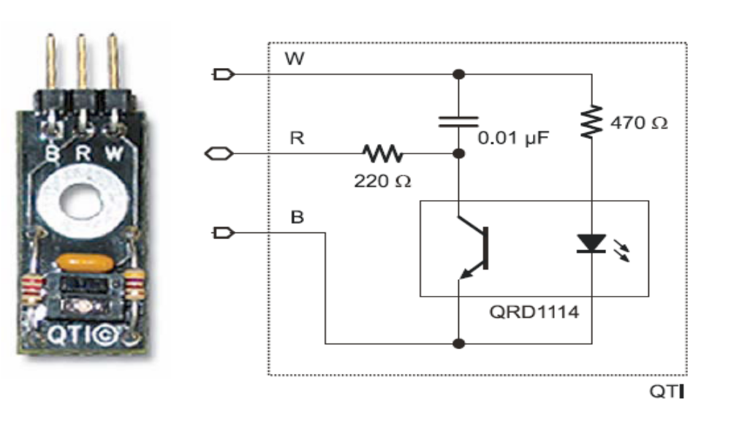
Figure 5
Modified QTI line following modules from Parallax are used for the line following. At the heart of the QTI module is the QRD1114 reflective object sensor. The QRD1114 reflective sensors consist of an infrared emitting diode and a NPN silicon phototransistor mounted side by side in a black plastic housing. The on-axis radiation of the emitter and the on-axis response of the detector are both perpendicular to the face of the QRD1114. The phototransistor responds to radiation emitted from the diode only when a reflective object or surface is in the field of view of the detector.
QTI module is modified as follows in order to output analog values.
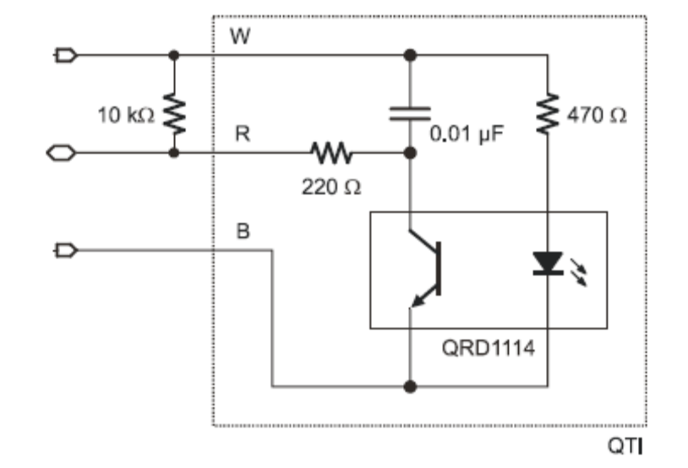
Figure 6
QTI output (analog) values are then fed to A/D pins of the Mavric IIB board.
Four QTI modules are used; two over a black line (line to be followed), one on the left of the black line, one on the right of the black line (in order to detect intersections).
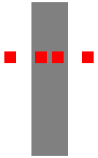
Figure 7

Distance/Object Avoidance

Sonar module (SRF04) will be used to measure the distance to a detected object.
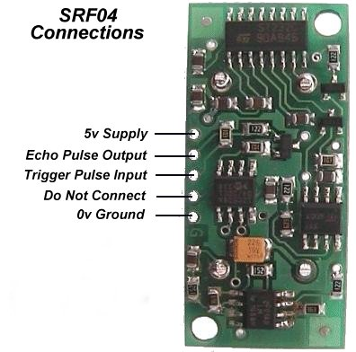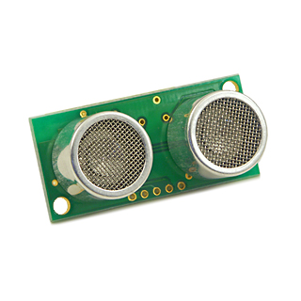
Figure 8
Above ultrasonic ranger that has an approximate range of 3" to 10'. This ranger has a logic line used to trigger a pulse and the echo is returned on a second line. To detect the range to an object ultrasonic sound will be sent out; when the sound hits an object it will bounce back and will be picked up SRF04. SRF04 module makes the use of Mavric IIB board’s input capture pins. One the trigger input is set, a timer is started which measures the time it takes for sound to come back. Knowing the speed of sound, distance to an object can be calculated based on the time it took for an echo to come back.

Communication

Robot communication with a computer or a PDA will be implemented with Bluetooth transceiver module from Parallax.
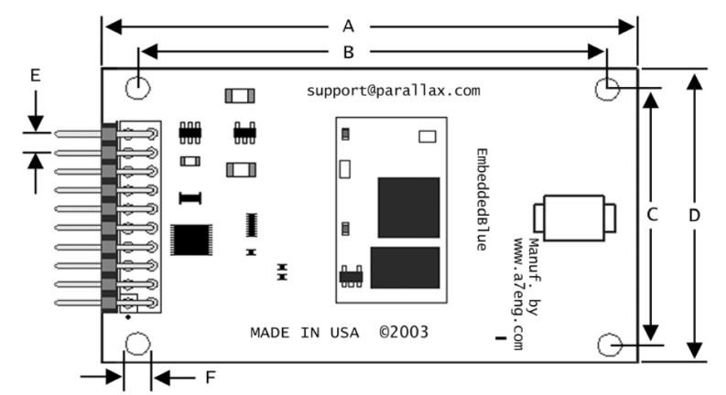
Figure 9
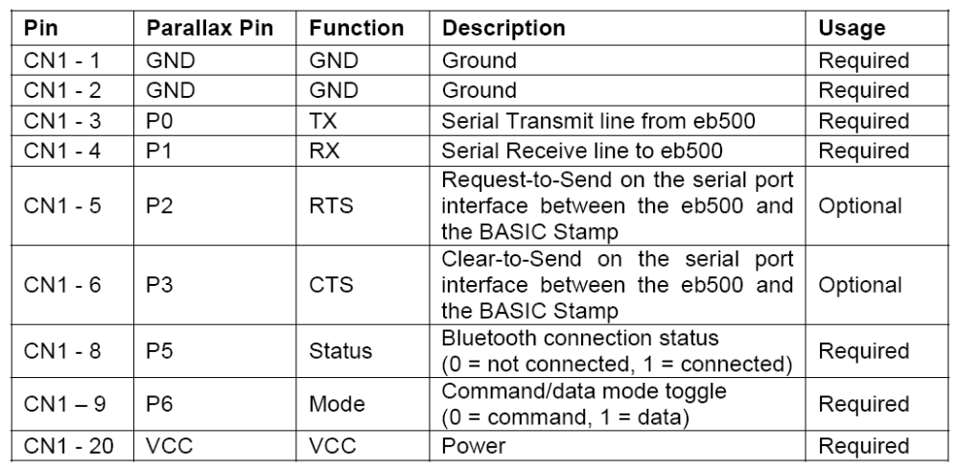
Bluetooth module is configured so that it is transparent, meaning that Tx pin from Bluetooth module is connected to Tx on UART 2 and Rx pin from Bluetooth module is connected to Rx pin on UART 2. CTS/RTS pins are not used. Mode pin on the Bluetooth module is an input from Mavric IIB and is manipulated by the code. In command mode, the module connects to a specified Bluetooth device. In data mode it acts as a serial port between Mavric IIB and the PC. Connection status pin is an output from the module and an input to the Mavric IIB board. When the module is connected, status pin goes true, but since the module operates using TTL level logic, status pin is only at 2.5V. This is not enough for the Mavric IIB board to reliably detect current module status. In order to fix this problem, a level shifter was used to step up the voltage up to 5V.

Object Identification
RFID reader (special sensor)
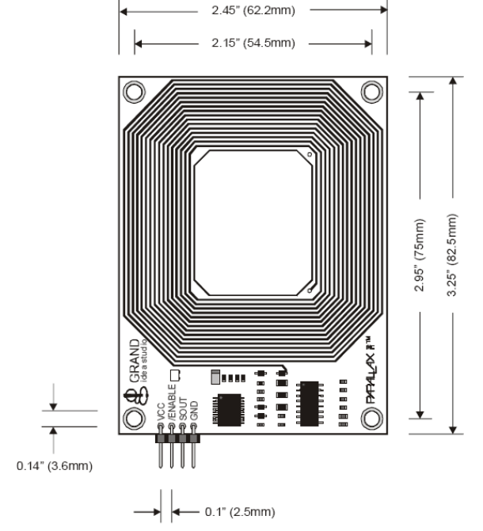
Figure 10
Introduction:
RFID system from Parallax is a fully integrated low cost system for reading passive RF transponders. The system consists of the reader and one or more tags. Once enabled, the reader turns on its’ antenna and starts emitting electromagnetic waves at a certain frequency. When a passive tag is placed within range of the EM waves generated by the reader, it activates and transmits its unique ID number to the reader.

Operation:
Once powered, the reader needs to be enabled with an active low enable signal. When this signal is detected the reader activates its antenna and starts emitting EM waves. Passive tags contain an internal antenna and the circuitry required to transmit unique ID stored in each tag. When the passive tag is placed in from of the reader, tag’s antenna captures EM waves emitted by the reader and converts them into electricity which in turn powers the circuitry required to send out the unique ID number. A tag needs to be placed within the maximum distance of 6cm from the reader for the read to be successful.

Configuration:
This system is fully integrated and very easy to implement. RF reader requires four inputs: VCC, GND, SEROUT, and ENABLE.
VCC is connected to +5V on the Mavric board
GND is connected to GND on the Mavric board
SEROUT is connected directly to the UART pin, because it uses TTL (2400 baud) interface.
ENABLE signal can be connected to any I/0 pin on the board. Enable can either be permanently connected to GND or any of the ports so it can be software controlled.
Application:
Autonomous warehouse inventory robot uses RFID reader to read “tagged” containers in the warehouse. When AWIR approaches an object it starts calculating its’ distance from the object, when that distance is about 5cm it stops enables the reader and attempts to read the tag. Assuming that an object is a container with a valid tag, reader will read the tag and transmit the unique ID number serially to the microcontroller. After the tag has been successfully read AWIR continues to roam the warehouse looking for other containers. Once the tag ID has been received by the microcontroller it needs to be stored as an array of elements. Using BASCOM AVR this can be implanted as follows:
Step 1: See if there is any UART activity
Re_check
Uart_status = Ischarwaiting()
If Uart_status = 0 Then Goto Re_check
Step 2: Before the reader starts transmitting tag ID number, it first transmits $0A character to identify that after $0A actual ID number will begin. So now we check if the first character is $0A if it is we’ll read the tag and store it as an array if it’s not we’ll check again.
Prefix = Inkey()
If Prefix = &H0A Then Goto Read_tag
'if character is not $0A, keep on checking
Goto Re_check
Step 3: Here we actually read the tag and store it as an array. The last character sent by the reader is $0D, this is how we know that tag read is complete
Read_tag:
'initialize/reset index
Index = 0
Do
Index = Index + 1
Tag_id(index) = Waitkey()
Loop Until Tag_id(index) = &H0D
Step 4: Because we need to be able to read multiple tags and distinguish between them, once the tag has been red it will immediately be compared to the already stored tag numbers. This process can be accomplished in various ways; however, for this project, known id numbers are stored in the EEPROM. Each time the microcontroller reads a tag it checks it against the tag ids numbers already stored in the EEPROM.

Conclusions:
RFID reader hardware is fully integrated, it’s a good thing when it comes to the ease of use, and it’s not so good when it comes to versatility. For my application, however, this is not an issue. The Reader hardware implementation is trivial. The reader software implementation could be a bit tricky depending on applications.

- Behaviors

Autonomous Warehouse Inventory Robot will navigate the warehouse via line following. Line to be followed will be strategically placed so that AWIR has easy access to any container in the warehouse. AWIR will constantly navigate warehouse, once it detects an object in its’ path it will try to scan the RFID tag. If the scan is successful, it will send the information contained within the tag to the warehouse computer. Upon an unsuccessful scan AWIR will try to reposition itself and attempt the scan again. If it is unsuccessful, it will move away from an object and continue wandering the warehouse constantly looking for RFID tagged containers.

- GUI

In order to better facilitate communication between AWIR and the warehouse PC a graphical user interface was designed and implemented in Visual Basic.

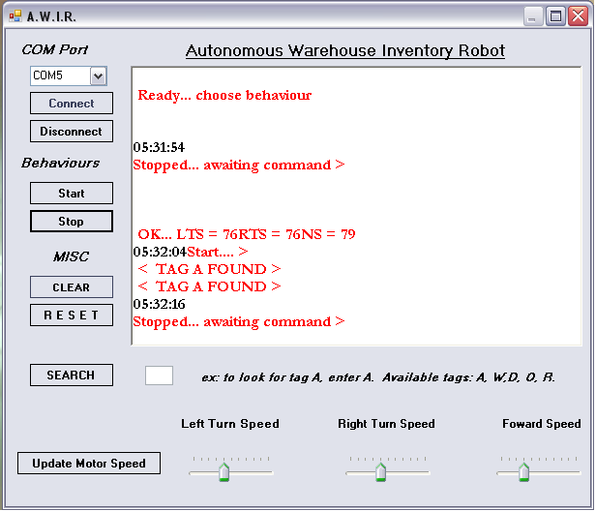
Figure 12

As can be seen from figure 12, the user is able to start or stop AWIR remotely. There is also a search function, but it is not implemented as well as it could be. As it all stands now, if “search” is activated, once AWIR finds the user specified container the user will be notified on the GUI. The problem is that, AWIR doesn’t really search for the container, it just roams the warehouse. To better accommodate the needs of the specific track motor speeds can be adjusted remotely.

- Experimental Layout and Results

Line following sensors
Modified QTI modules from Parallax worked very well. After the original circuit was modified as shown in figure 6, I was able to get analog output from the modules and feed it too A/D. With a sensor on the white surface A/D values ranged from 70 – 180, with a sensor on a black surface A/D values ranged from 600 – 1024. In the code the A/D values were digitized meaning that if a value is less than 300 it’s a zero, if it is more than it’s a one.

Sonar
Referring to figure 8,
Sonar Module | Mavric IIB
Trigger Pulse | Any I/O pin
Echo pulse | Input capture pin
Using this interface, we can measure the time it takes for an echo to come back. Knowing the speed of sound, distance can be calculated or output could be taken as raw data. In my code I’ve calculated the distance in centimeters, therefore I made no data tables. Overall sonar worked very well for my application.

RFID module
Hardware implementation of the module is very simple, due to the fact that the module comes fully integrated. Software implementation could be a bit tricky depending on application. For this particular project, software implementation proved to be relatively straight forward. For more information in the RFID system, please see “Sensors” section.

H-bridge
H-bridge provides control for the DC motors. H-bridge implementation is straight forward: logic inputs are connected to Mavric IIB and H-bridge outputs are connected to the DC motors. With this H-bridge the speed of the motors can be adjusted in one of two ways. First way, voltage supplied to the H-bridge can be varied, while the enable inputs are always kept as true. Second way, a constant voltage can be supplied to the H-bridge, while the enable inputs are pulsed with PWM. I have chosen the second way because it is easier to vary the motor speed with software than it is with hardware.

Bluetooth Module
Bluetooth module is essentially an extension of the UART. Actual hardware implantations is not difficult as long as Tx pin from the module is connected to the Tx pin on the Mavric IIB board, and Rx pin from the module is connected to the Rx pin on the Mavric IIB board. There are two modes, command and data. In command mode various commands such as connect, disconnect, security setup, etc. can be issued to the module. In data mode, whatever is sent serially (from the UART) to the module will be transmitted to the target Bluetooth device.

- Conclusion
Overall the AWIR project turned out to be successful. Prototype unit performed as well as expected. It was able to roam the “warehouse” in a predetermined path, at intersections choosing random directions, and scan tagged containers.
Communication between AWIR and PC worked very well, I was able to implement the Bluetooth module without any problems (that is only after I figured out that it is suppose to be transparent).
Line following worked well, but if I could do it all over again I would have definitely used encoders for the DC motors. If the encoders were used, it would have saved me a lot of manual tuning of the motors, especially for turns.
AWIR is able to scan tagged containers most of the time, however, sometimes it fails. Since I have spent a lot of time in hopes of improving my tag scan function and failed, I must conclude that the particular hardware used is not completely adequate for my application. Given the fact that this project is only proof of concept, I will deem it to be a success.
“Hands on” learning experience is the best way to learn. IMDL is the hands on learning experience.

- Acknowledgements

I’d like to thank the following people for their contributions to the AWIR project:
Chris Vidal for the original idea,
Rolando Estrella for the help with Bluetooth as well as other support,
Nichole Anderson for all the emotional support,
and Kristina for making it all possible.

- References

www.Parallax.com
QTI Line Follower AppKit for the Boe-Bot (#28108) [Documentation]
EmbededBlue 500 User Manual [Documentation]
RFID user manual [Documentation]

www.BDMicro.com
Mavric IIB manual [Documentation]

http://www.superdroidrobots.com/product_info/SRF04.htm
Info on SRF04 sonar module

http://mil.ufl.edu/imdl/handouts/default.htm
Reliable Line Tracking by William Dubel

XIV. Appendices

I wrote all my code in BASCOM AVR, it is posted at:
http://plaza.ufl.edu/globuso/IMDL.html
Code for the GUI is written in Visual Basic, it is posted at:
http://plaza.ufl.edu/globuso/IMDL.html

